ICT companies are welcome to join our ICT hub, please submit your online application and **APPLY NOW via our online system. Cheers!**

1. **Sign up and Login** <https://www.hohojo.com/en/page/building/14604>

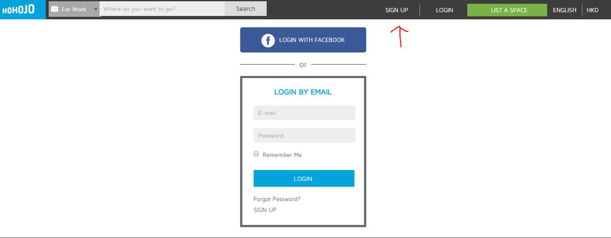

1. **Browse this direct link** <https://www.hohojo.com/en/serviced-office/detail/34710> and Click **APPLY NOW**

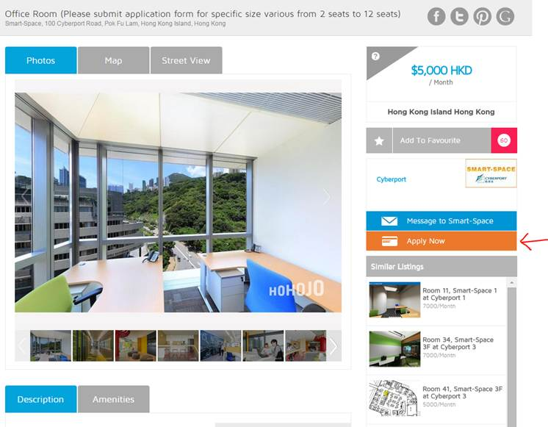

1. **Complete by Filling the e-form**

